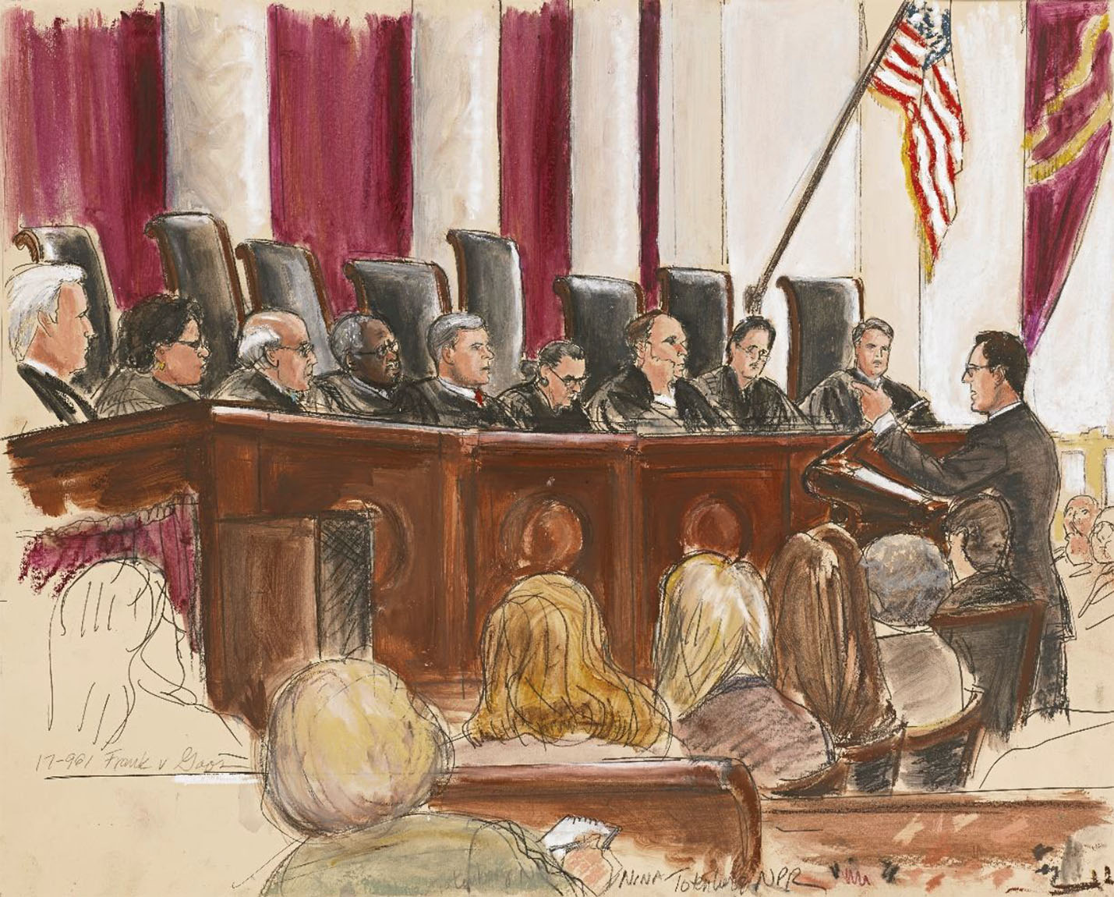

Bentley University: Philosophy Department
PH110 Debating Ethical Problems
Fall Semester 2025
Wednesdays 11:00am-1:50pm

Instructor: Dr. Kelly Cunningham
Office Location: Jennison 221
Email: kcunningham@bentley.edu
Office Hours: Mondays and Wednesdays 2:00-3:15 (in person), Tuesdays 12:00-2:00pm (via Zoom) or by appointment

Course Image: Supreme Court of the United States of America by courtroom sketch artist Elizabeth Williams

COURSE DESCRIPTION
This philosophy course is, unusually, centered not around a topic but a skill – the skill to debate controversial topics effectively, reflectively, and respectfully. It is modelled on the Association for Practical and Professional Ethics (APPE) Intercollegiate Ethics Bowl Competition, in which undergraduate students compete by discussing an ethically sensitive topic of everyday interest. Students enrolled in the course will be eligible to compete in this competition on Bentley’s team (see next section). The course is centered around the topics that the American Society for Applied Ethics provides annually in preparation for the competition. The case studies covered in this class will include important ethical topics, and while the course will cover various important ethical theories and concepts, the primary goal will be learning how to develop and defend a point of view related to hot-button ethical issues, while also being receptive to the viewpoints of others.

The course consists in practicing the development of arguments and counter-arguments that are based on these topics. While such arguments have ethical content, ethical theory remains in the background of the course, whose main aim it is to learn how to develop and defend a point of view, as well as listen well to the viewpoints of others.

OPTIONAL REGIONAL COMPETITION PARTIPCATION
Students in this course are eligible to participate in the APPE Northeast Regional Ethics Bowl Competition, which will take place Saturday, November 15th at Northeastern University or the Online Regional Ethics Bowl Competition on Saturday, November 8th. Official teams will be determined based on student interest and availability, and, if necessary, by a mock-round competition judged by professors in Bentley University’s philosophy department no later than week 7. In addition to practicing in-class, we will have two additional practices prior to the competition, the dates/times for which will be selected based on team members’ availability.

COURSE EXPECTATIONS
This is an intro-level course, which means students are not expected to have prior philosophical knowledge. However, you are expected to…
- Complete the readings before class on the day they are assigned and complete assignments when they are due. See the course schedule at the end of this syllabus for details.
- Be respectful! Many of the cases we discuss and debate in this course are controversial. Spirited debate is encouraged, but disrespectful behavior (toward your instructor or your classmates) will not be tolerated.
- Attend all class meetings and participate! In-class participation is a significant portion of your grade this course. Your participation in mock rounds will be evaluated using the rubric found under the “Participation” section of this syllabus. Given that this course only meets once a week, I permit one “no-questions asked” absence per semester.
- Reach out via email or come to office hours if you have questions about the course material, your grade, or assignments.
- Inform me if you are struggling to complete assignments or anticipate needing an extension.

For this course, you can expect me to…
- Answer emails within 48 hours during the week (M-F). I try to stay off my email after 8pm, so anything received after that time will be responded to the following morning. I check my email less frequently on weekends, so if you email me then I may not respond until Monday morning. Depending on the nature of your inquiry, I may suggest we meet during office hours. (FERPA regulations limit what I can write about grades in emails and sometimes it can be difficult to do philosophy over email!)
- Be available during my scheduled office hours (or by appointment) answer any questions about the course material or assignments.
- Communicate any changes to the syllabus or my office hours schedule via our course weekly announcement on Brightspace
- Look over drafts or outlines of your assignments for this course, provided a reasonable time frame (I usually require at least 48 hours to read and comment on a draft/ assignment before a meeting).
- Update the gradebook on Brightspace in a timely manner.

COURSE OBJECTIVES
Below you will find the objectives of this course:
- To develop a basic understanding of ethical concepts
- To be able to identify and understand rhetorical forms and strategies used in ethical debates and case study write-ups
- To apply key concepts and principles from those theories to contemporary ethical problems
- To engage meaningfully with a diverse array of perspectives
- To deconstruct and think critically about contemporary ethical problems

COMMUNICATION INTENSIVE OVERVIEW
This course meets your degree requirements for communication intensive curricula: presentations on case studies involve communicating your ideas, vision, concepts, and approaches to your work. Mock rounds require careful listening, the ability to respectfully disagree, and constructing coherent arguments. Students are expected to actively participate in the following ways:
- Active participation in team mock rounds
- In-class presentations on case studies (x2)
- Written feedback for peers in class
- Completion of AI Counter Argument Assignment & In-Class Activities

CONTEXT AND PERSPECTIVES: VALUES, ETHICS, AND SOCIETY
This course also meets your context and perspectives course criteria in the following ways.
- You will learn to distinguish between facts and values by analyzing contemporary case studies
- You will encounter 15+ ethical issues that arise in public life and learn to discuss them from competing moral perspectives
- You will develop the ability to articulate and critically assess features of society, such as laws, regulations, social norms, business practices, or personal beliefs, actions, and characteristics

TEXTS & OTHER COURSE MATERIALS
Please bring a writing utensil, something to take notes on, and the assigned text to class every day. All readings will be available on Brightspace. No textbooks are required for this course.

COURSE ASSIGNMENTS, GRADING SCALE, & BREAKDOWN

Your final grade will be calculated based on the points you earn for each of the assignments in this course. I use Bentley’s standard grading scale for assigning letter grades at the end of the semester. Extra credit opportunities outside of class require additional time and since not all students have equal access to leisure time, extra credit tends to disadvantage student-parents, students who provide care for other family members, and students who work. For this reason, I only offer extra credit opportunities during regularly scheduled class time.

Grade Point | Letter Equivalent | Numerical Equivalent
4.0 | A | 95-100
3.7 | A- | 90-94
3.3 | B+ | 87-89
3.0 | B | 83-86
2.7 | B- | 80-82
2.3 | C+ | 77-79
2.0 | C | 73-76
1.7 | C- | 70-72
1.3 | D+ | 67-69
1.0 | D | 63-66
.7 | D- | 60-62
0.0 | F | Below 60
P | C- or better | 70 or better

Participation (40%)
The participation category of your grade for this class is substantial because a significant portion of our time-class is devoted to class discussion and mock debates in the APPE Ethics Bowl format. Early in the semester, our class will be divided into four teams. During each class two teams will compete in the mock round. During these rounds, I will track and evaluate team members’ participation using the rubric below. On weeks when your team is not competing in the in-class round, your team members will complete a self and a team evaluation during the mock round portion of class. Your final participation grade will be based on your participation in class discussions and other activities, your efforts to contribute to your team’s presentation in mock rounds, and your team and self-evaluation worksheets. Feedback on your performance in mock round practices will be provided regularly throughout the semester.
Mock Round Participation Rubric

Criterion | Outstanding (3) | Meets Expectations (2) | Needs Improvement (0-1)
Ethical Issue Recognition | Student’s contributions to presentation recognized ethical issue at hand in the question/ case. Multiple layers of the issue were presented Description of ethical issue was presented in a complex, multilayered way and student acknowledged cross- relationships among this issues and others like it. | Student’s contributions to presentation recognized basic and obvious ethical issues and grasped (incompletely) the complexities or interrelationships among the issues. | Student’s contributions to presentation recognized basic and obvious ethical issues but failed to grasp complexity or interrelationships.
Delivery | Delivery techniques (posture, gesture, eye contact, and vocal expressiveness) made student’s contributions to team’s presentation compelling, and speaker appears polished and confident. Student transitioned well from previous speaker, and/or introduced/ concluded the presentation effectively | Delivery techniques (posture, gesture, eye contact, and vocal expressiveness) make the presentation interesting, and speaker appears comfortable. Transitions, introductions and/or conclusions were present, but may have been abrupt or unclear. | Delivery techniques (posture, gesture, eye contact, and vocal expressiveness) detract from the understandability of the presentation, and speaker appears uncomfortable. Transitions, introductions, and/or concluding statement may have been abrupt, involved talking over other group members, or been difficult to follow.
Civil Communication Skills | Student tailored communication strategies to effectively express, listen, and adapt to the opposing team’s questions and refutations. | Student’s communication to opposing team shows ability to do more than one of the following: express, listen, and adapt ideas and messages based on others' perspectives, questions, and refutations. | Student’s communication with opposing team demonstrated the ability to do one of the following: express, listen, and adapt ideas and messages based on others' perspectives.
Answer, Analysis & Application | Student organized and synthesized evidence to reveal insightful patterns, differences, or similarities to offer an answer to the question in the round. Student correctly applied ethical concepts in their analysis and answer in an intriguing and/or novel way. | Student organized evidence, but the organization was not effective in revealing important patterns, differences, or similarities related to the question in the round. Student used ethical concepts in their analysis and answer, but minor errors or inconsistencies may have been present. | Student listed evidence, but it is not organized and/ or is unrelated to the question in the round. Application of ethical concepts contained significant misunderstandings of the concepts covered in class.
Total: /10 points (note it is possible to earn 12/10 if 3’s are earned across the board. I will use your average score from all mock rounds to calculate your final grade for this category.)

APPE Ethics Bowl Case Breakdown Worksheet (5%)
Early in the semester you will be assigned one of the cases from the APPE Ethics Bowl case list. Using the worksheet available on Brightspace, you will break down the core elements of your case on the worksheet to help you prepare for your presentation. Your case breakdown worksheet is due on Brightspace by midnight on the Friday before the day of your presentation, as this will provide me with time to give you feedback before you present in class the following Wednesday. You are encouraged (though not required) to come to my office hours before your presentation or before you complete this worksheet. An example of a completed worksheet and a rubric are also available on Brightspace.

APPE Ethics Bowl Case Presentation (15%)
Using your Case Breakdown Worksheet as a guide, you will deliver presentation with a partner on your assigned case once during the first half (or so) of the semester. Your presentation should include all the elements listed on the case breakdown worksheet, though how you organize and deliver the presentation is up to you and your partner. Your presentation should be 10-15 minutes long and you should plan for ~5-10 minutes of questions/ class discussion. A rubric outlining how your presentation will be graded is available on Brightspace. During class, we will develop an understanding of rhetorical forms and strategies for presenting case studies.

AI Case Counter-Argument Activity (2 x 7.5% each= 15%)
Twice during the semester, we will utilize AI tools to widen our perspective on the cases we cover in class. In class, you will be asked to free write an answer to a question about a case (different from the one you present on). Then, you will ask AI to generate three counterarguments or objections to your answer. To complete the assignment, you will be asked to rank which counterarguments you think are strongest and explain your ranking. We will use these AI-generated responses for an in-class activity on the day they are due. We will go over an example together in class at least two weeks before the first of these assignments is due.

Final Assignment (25% total)
Your final assignment will consist of four components: a draft, an in-class presentation, peer evaluations, and a case write-up. A rubric and full description of the requirements for the presentation, peer evaluations, and the case-write up component are available on Brightspace. We will also spend time in class discussing rhetorical forms and strategies appropriate for case-study write-ups. You have the choice of completing your final assignment individually or with a partner. Please note that regardless of when you present you are expected to attend the final exam block, as you will complete your peer evaluations on a day that you do not present.

Presentation (10%):
Early in the semester, we will determine final assignment presentation days for each student. Your presentation should be based on your case study write-up draft and should run between 7-10 minutes long (not including time for discussion after).
Case Write-Up Draft (2.5%):
A draft of your case write-up is due on the day of your assigned presentation. You will receive feedback from me on your draft and presentation to incorporation into your final write-up.
Peer Evaluations (2.5%)
You will complete peer evaluations for your classmates during class time on days that you are not presenting. These will be graded on a check -, check, check + scale. An average of a check or higher will earn you full points for this category of your grade.
Final Case Write-Up (10%)
Your final for this class is a revised version of your case study write-up draft which should incorporate the feedback that you receive from your classmates and myself. Your case write-up should be ~1000 words. Half a letter grade will be deducted from write-ups that are more than 300 words under or over 1000. This part of your final assignment is due by midnight on the day of our scheduled final exam: Monday, December 15th, though you are more than welcome to turn it in earlier.

POLICIES AND PROCEDURES

All courses offered at Bentley University reflect our institution’s commitment to a set of core values and practices. The links below will take you to full explanations of our policies and procedures related to accommodations and equitable learning environments. As a student, you are expected to review and be familiar with each of these policies:

Bentley’s honor code and academic integrity system

Equity and bias reporting forms and procedures

Student Disability Accommodations

Religious observances

Bentley’s core values

The links above spell out these policies in more detail, but I have copied several policies below for your reference.

FERPA COMPLIANCE REMINDER
To protect student privacy, FERPA guidelines state that professors are not to discuss grades via email. If you would like to discuss your grades, please come to office hours, email me to make an appointment.

TECHNOLOGY AND AI USE POLICY COURSE REQUIREMENTS
You may use laptops/ tablets only to reference readings or take notes during class. If you are seen using your laptop/tablet for other purposes, I will ask you to put your device away for the rest of class. Your right to use such devices may be revoked if this becomes a recurring issue. Your cell phone, earbuds, or headphones should not be used during class. I will call you out if you are using them or your laptop/tablet for purpose unrelated to this course. If the behavior persists you receive a zero for participation that day. If you are anticipating a time-sensitive phone call during class time, please inform me at the start of class and plan to take your call outside the classroom.

You may use AI as directed for your AI counter-argument assignments in this course. If you choose to use AI tools of any kind for your draft or final case write-up, you must include a statement of what AI tool you used and how. If you use AI tools to create an outline, please include that outline as part of your assignment submission along with your statement. If you use AI tools (including Grammarly etc.) to edit your writing, please include one example of a “before and after” that illustrates how you used this tool. If you use AI tools to complete assignments or parts of assignments without disclosing your use, your grade will be penalized, and you may be reported to the Honors Council.

ACADEMIC INTEGRITY

All students are expected to adhere to Bentley’s Academic Integrity policy and Honor Code, which can be found on Brightspace and in the Undergraduate Student Handbook/Graduate Catalog. The policy essentially states that a student should not represent someone else’s work as his or her own. Plagiarism, cheating on exams or quizzes; or other instances of academic dishonesty will result in an “F” (0) on the assignment, and possibly for the course. Serious and/or repeated violations of our AI policy will also be reported. In short, do not cheat. If you are struggling to complete assignments or understand course material, come to office hours, or arrange a time to talk with me.

ACCESSIBLITY & ACCOMODATIONS

The Office of Accessibility Services is responsible for managing accommodations and services for all students with disabilities and/or accessibility needs. The Office of Accessibility Services is located in the Office of Student Success (JEN 336). If you have a hidden or visible disability that requires classroom accommodations, please call the Office of Accessibility Services within the first 4 weeks of the semester to schedule an appointment.

If you are comfortable disclosing, please notify me privately if you have accessibility needs that will interfere with the completion of work for this course or that requires other forms of accommodation. If you are unsure of how to obtain accessibility accommodations, email me. I am more than happy to help you get in touch with the right people!

ATTENDANCE POLICY
I understand that conflicts may arise, so I allow one “no-questions-asked” absences over the course of the semester. You can use this absence for any reason (job interview, mental health day, routine appointment, attending a wedding, etc.). Excused absences will also not count against you. Excused absences include absences due to illness, travel for unplanned family emergencies, and co-curricular activities that are excused by your coach/advisor. Notice is expected for excused absences beyond your one “no questions asked” absence. Excessive absences will be reported through the proper channels. It is acceptable to leave early or arrive late on occasion, I just ask that you do so quietly and in a way that respects our learning environment. Patterns of lateness or early departure from class, as well as violations of our technology use policy will adversely affect your final participation grade. In compliance with federal guidelines and Bentley University Academic policy, students who do not attend or engage academically in any courses during the first week of class will be designated as a “no show” and will be dropped from the course.

COURSE SCHEDULE

Date | Topic & Short Agenda | Readings to complete before class | Assignments Due  (at Start of Class unless otherwise indicated)
Week 1 | Welcome Week
9/3 | Syllabus Scavenger Hunt, Introduction to APPE Ethics Bowl Format, Case Study Breakdown Practice | N/A | Review 2025 APPE Ethics Bowl Case Study Options and select your top three choices. Write them on an index card or piece of paper and slip it under my office door by Monday 9/8 at 5pm.
Week 2 | APPE Ethics Bowl & Core Ethical Concept Overview
9/10 | Core Concept Overview Part I, Review 2024 Cases, Mock Round Practice, | 2024 APPE Ethics Bowl Cases #2 and #6  “Commonly Used Ethical Principles” Pages 1-5 (stop at “Social Contract Ethics” section)
Week 3 | Presentation Skills: Presentation & Debate Communication Basics
9/17 | Lecture on Presentation Organization & Structure, Overview of Ethics Bowl, APPE Case Presentations 1 &2, mock round practice | Case #1 & Case #2  Read: “The Growth of Ethics Bowls” by Lisa Lee (PDF on Brightspace)
Week 4 | Presentation Skills: Counter-arguments
9/24 | Core Concept Overview Part II, Go over AI Counterargument assignment example, APPE Case Presentations 3&4, mock round practice | Case #3 & Case #4  “Commonly Used Ethical Principles” Pages 6-11 (you can skip the descriptions of individual philosophers’ views on pages 6-8)  “The Ethics of Care as Moral Theory” by Virigina Held, Pages 9-15 (stop at “Justice and Care” section heading) | Example of AI Counter Argument Activity Available
Week 5 | Argument Evaluation & Fallacy Identification
10/1 | Counter Arguments & Refutations Lecture, APPE Case Presentations 5&6, mock round practice | Case #5 & Case #6  “Four Step Refutation”  https://www.comm.pitt.edu/four-step-refutation
Week 6 | Presentation Skills: Counter Arguments continued
10/8 | Group Counter Argument Activity, APPE Case Presentations 7&8, mock round practice | Case #7 & Case #8  Read: Hoffman Business Center “Business Ethics: What everyone should know” | AI Counter Argument #1 due at start of class on Brightspace
Week 7 | Mid-Semester Check in & Presentation Skills: Effective Introductions & Concluding Statements
10/15 | Mid-Course Evaluations, Evaluating Arguments & Identifying Fallacies Activity, APPE Case Presentations 9&10, mock round practice | Case #9 & Case #10  “Fallacies”  https://owl.purdue.edu/owl/general_writing/academic_writing/logic_in_argumentative_writing/fallacies.html
Week 8 | Presentation Skills: Responding to Questions and Counterpoints
10/22 | Lecture on effectively responding to questions and objections APPE Case Presentations 11&12, mock round | Case #11 & Case #12
Week 9 | Writing Skills: Transitioning from Presentation to Case Study Write-Up
10/29 | Lecture & activity on translating oral presentations to writing, APPE Case Presentations 13&14, mock round | Case #13 & Case #14 | Be prepared to choose final presentation date & have 1-2 cases in mind
Week 10 | Writing Skills: Raising Questions & Objections in written form
11/5 | HCBE Panel Question Workshopping  APPE Case Presentation 15  Mock Round Practice | Case #15 | AI Counter Argument Assignment #2 Due on Brightspace by start of class
Week 11 | Mock Round Finals
11/12 | Final Case Presentations  Mock Round Practice | N/A | Regional Competition (for team members only) Saturday, November 15th at Northeastern University
Week 12 | Final Assignment Presentations
11/19 | Final Case Presentations | N/A
Week 13
11/26 | Thanksgiving Break-No Class Meeting
Week 14 | Final Assignment Presentations
12/3 | HCBE Affiliate Panel Q&A: Navigating Ethical Dilemmas in the Workplace  Final Case Presentations | N/A
Finals Week
 | Final Case Presentations  *Finals Week Meeting is Monday, December 15th from 3-5pm* |  | Case Study Write-Up due by Midnight on Scheduled Final Exam Day, Monday 12/15 (turn in via Brightspace)

ADDITIONAL RESOURCES

Writing Center
The Writing Center offers one-on-one tutoring for writing and presentations, for students of all years and skill levels. Located on the lower level of the Bentley library (room 023), the Writing Center provides a welcoming and supportive environment in which students can work on writing or presentations from any class or discipline. Students are encouraged to visit at all stages of the process; they can bring a draft, an outline, or just some initial thoughts and questions. Staffed by highly skilled student tutors, the Writing Center is open six days a week, with conferences available online or in-person. Students are encouraged to make appointments in advance. Appointments can be made at https://bentley.mywconline.net. Hours and additional information are available on the Writing Center SharePoint site.

ESOL Center The English for Speakers of Other Languages Center
The ESOL Center, located in the lower level of the library, Room 026) offers writing and English language support to students who are English Speakers of Other Languages (ESOL). Its faculty tutors specialize in working with multilingual writers and can provide feedback and strategies on writing for all your course and career-related writing. Day and evening appointments can be scheduled through https://bentleyesol.mywconline.net or by dropping by the ESOL Center to see if a faculty tutor is available.

